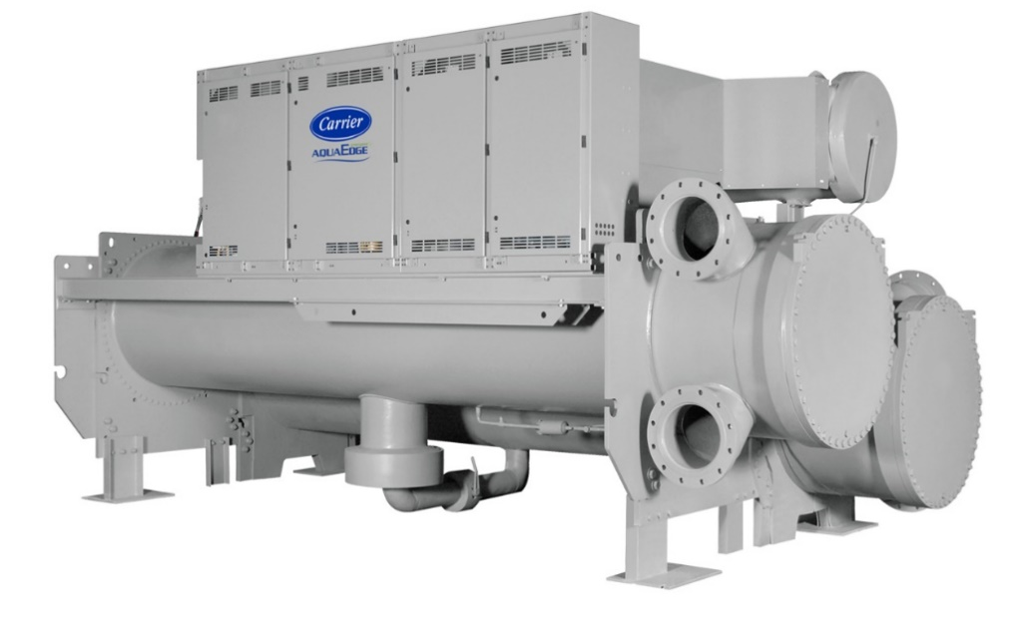

Device Information

Chiller Number | $ChillerSN
Location Name | $LocationName
Location City | $LocationCity
Postal Code | $PostalCode
Site Address | $SiteAddress
Time-zone | $TimeZone
Year of Manufacturing (Age) | $Age
Model Number | $ModelNum
Report Duration | $StartDate ~ $EndDate
Chiller Run Hours | $runhrs

Summary
As part of Carrier’s connected chiller program our command center experts continuously monitor performance and health of your chiller and its major components to provide real time feedback and less operational disruption.
Your chiller serial number $ChillerSN was evaluated for Chiller Replacement Analysis. Further Analysis is performed from the real time data from $StartDate to $EndDate. The design efficiency of current chiller is $Design_Efficiency kW/T. The overall efficiency of this chiller is $Efficiency_before kW/T. Replacing this with a Carrier Aqua Series Water Cooled Chillers can improve the overall efficiency to $Efficiency_after kW/T. This replacement can improve the chiller efficiency by $Efficiency_rate%. The chiller is running at low loads (<60% RLA) for $lowloadsRate during the analysis period and this replacement can enhance design integrated part-load values (IPLV) to as low as $IPLV_Efficiency kW/T.
Chiller Replacement Benefits:
- Improved Efficiency
- Reduces operating expenses.
- Easy to maintain.
- Quiet operation
- Reliable operation
- Environmentally sustainable refrigerant
- ASHRAE 90.1 compliant
- High-efficiency optimization
- Diagnostic controls

Based on the performance of the chiller operation versus measured parameters, Carrier recommends further evaluation of the Chiller Replacement by our certified technician. This will ensure optimal performance of the Chiller.
Alarm/Setpoint Analysis
There are no alarms during this period.
$alarm_count
The analysis result show that setpoint not meeting $setpoint_deviation% of time.
$Supply Chilled Water
$Return Chilled Water

$Entering Condenser Water
$Leaving Condenser Water
Comments
The Average Cooler supply water temperature is between $min_LCW to $max_LCW (°$T_Unit) and the average Condenser entering water temperature is between $min_ECDW to $max_ECDW (°$T_Unit).
$Chiller Power Consumption
$COPPLC
$Chiller COP vs %RLA
$effi_PLC_ECDW
$effi_PLC_1ECDW
$Runningtime&PLC
$P_CompareCOP
$VFD retrofit saving potential
$AfterBeforeCOP&PLC
$Power&Saving&SavingRate
Chiller Sub System Health

Chiller # | Condenser Health (Good/Stage of Degradation) | Evaporator Health (Good/Stage of Degradation) | Compressor Performance (Good/Stage of Degradation) | Ref leak (Good/Stage of Degradation) | Condenser Water Flow Issue (Yes/No) | Evaporator Water Flow Issue (Yes/No)
$ChillerSN

S1 | No action required
S2 | Plan to clean/fix
S3 | Clean/Fix immediately
S4 | -
Summary
Energy Efficiency Improve | $SaveRate%
Energy Savings | $SavePower kWh
Energy Savings/per year | $SaveP_peryear kWh
Investment pay-back period | $Payback_years Years

